|  |  |  |  |  |  |  |  |  |  |  |
| --- | --- | --- | --- | --- | --- | --- | --- | --- | --- | --- |
| |  | | --- | | Our Purpose | | Special Olympics LOCAL PROGRAM is made up of passionate, committed individuals from every walk of life. We recognize the value and unique gifts of people who have intellectual disabilities.  Together, we share the common belief in dignity, equality and opportunity for all people. | |  |  | |  | | --- | |  | |  | | 46 Louis Prima Dr., Ste A  Covington, LA 70433 | |  |  |

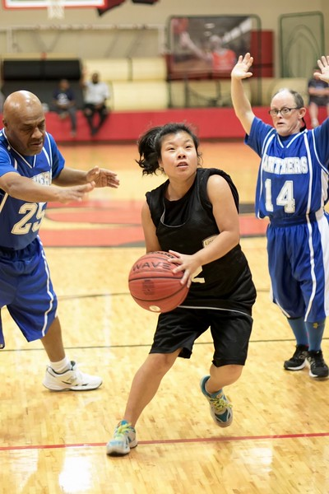

Special Olympics LOCAL PROGRAM

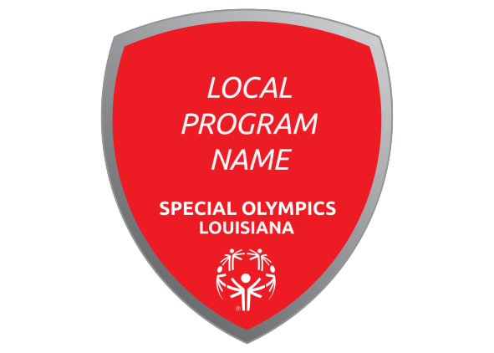

|  |  |  |  |  |  |  |  |  |  |  |  |  |  |  |
| --- | --- | --- | --- | --- | --- | --- | --- | --- | --- | --- | --- | --- | --- | --- |
| |  | | --- | |  | | Special Olympics Louisiana The mission of Special Olympics is to provide year-round sports training and athletic competition in a variety of Olympic-type sports for children and adults with intellectual disabilities, giving them continuing opportunities to develop physical fitness, demonstrate courage, experience joy and participate in a sharing of gifts, skills and friendship with their families, other Special Olympics athletes and the community. | |  |  | |  | | --- | | Sports in LOCAL PROGRAM  * Basketball * Bowling * Soccer * Softball  Events Soccer: Friday, September 13 – City  Bowling: Thursday, October 10 – Park  Christmas: Monday, December 9 – Location  Basketball: Friday, February 21 – Field  Softball: Friday, April 17 – Town  Fun Day: Friday, May 1 – Program  Swimming: Tuesdays/Thursdays – Practice  **Special Olympics LOCAL PROGRAM Committee Meetings:** *Everyone is welcome to attend.*   * Date: Third Thursday of the Month * Time: 6:00 p.m. * Location: New Horizons Adult Day Center | |  | |  | |  |  | |  | | --- | | We want YOU to get involved with Special Olympics Louisiana! Visit www.laso.org to learn more!   * Become an athlete! * Learn about volunteer and leadership opportunities in your community. * Fundraise in support of Special Olympics sports programming.  Goals Our goals as a local program are to focus on obtaining growing support and help build awareness and establish connections with important organizations and local government.  The local program steering committee will work tirelessly to ensure a quality sports experience for Special Olympics LOCAL PROGRAM athletes and an inclusive environment for them and their families. To help improve the lives of people with intellectual disabilities and build a better, more accepting community in LOCAL PROGRAM NAME. | |  | | Contact Us  Local Program Coordinators:  Contact Name  Phone  Contact Name  Phone  Email: [____________](mailto:yadkin@sonc.net) Website: [www.laso.org](http://www.laso.org) | |